WebAPI
Exercise 5
- Code
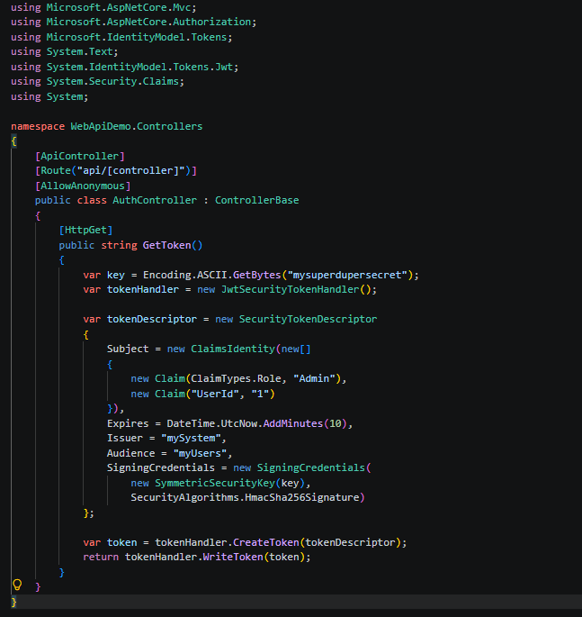

- Output
Token Generation
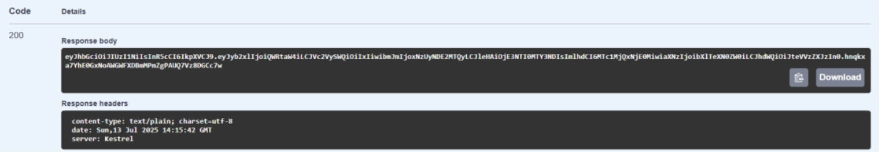

Authorization
